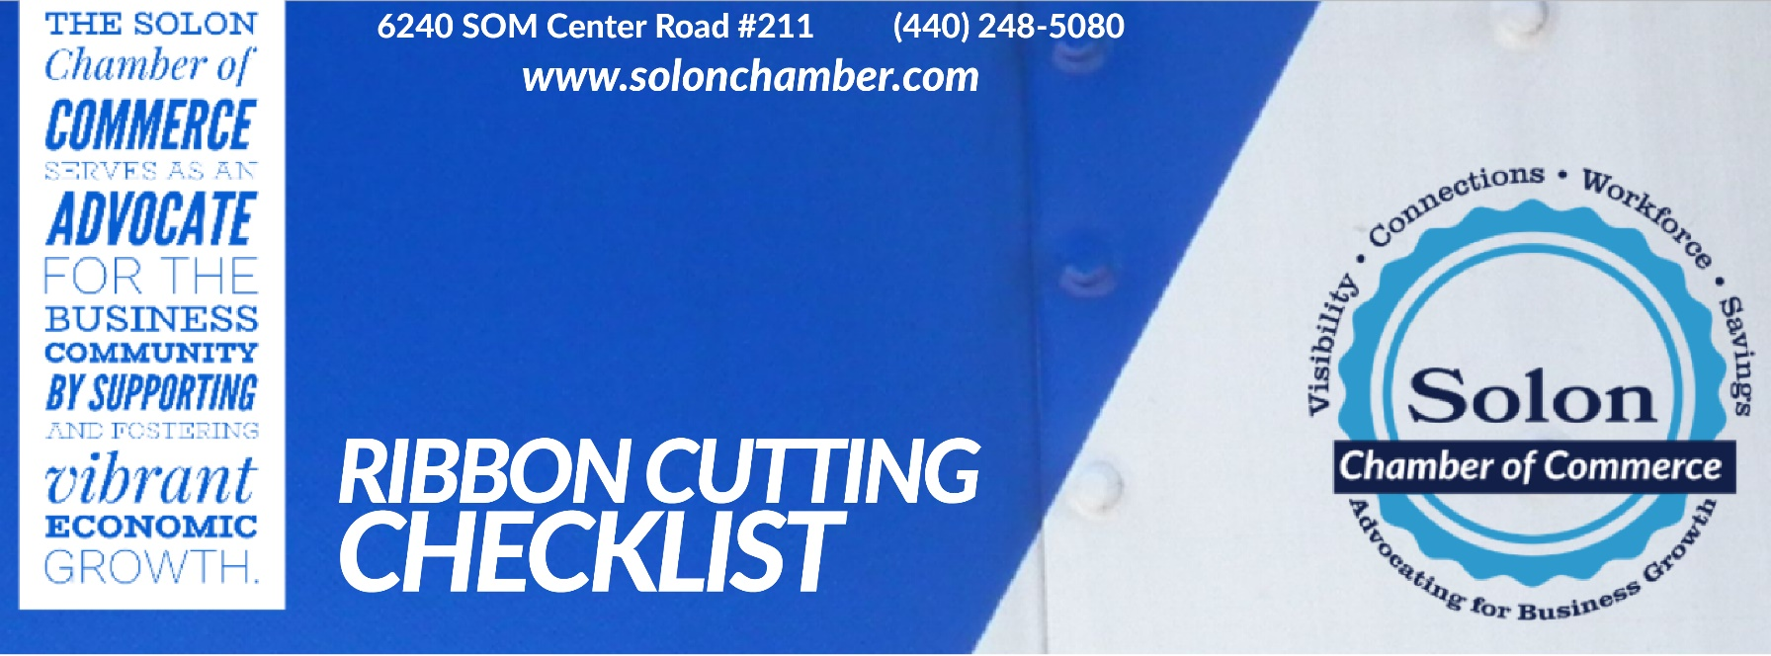

The Solon Chamber of Commerce would love to celebrate your business or organization’s milestone! A Ribbon Cutting Event is a great way to bring businesses and the community together to celebrate the vibrant energy and growth of Solon, Ohio! This checklist will help us make your event the best it can be. If you have additional questions, please email president@solonchamber.com!

Reason for ribbon cutting:
New business in town
New location
Remodeled space/expansion
Significant business anniversary
Other

What day will your ribbon cutting be? Ideally, pick a date 4-6 weeks away:
Preferred Date & Time*: Backup Date & Time 1: Backup Date & Time 2:
*Note: Please plan for the physical ribbon to be cut approximately 15-20 minutes after start time

We need the Chamber to:
Bring the Scissors & Ribbon
Invite the Mayor & Councilmembers to attend
Invite State & Federal Officials (or representative from their office)
Invite Chamber Members to attend
Announce ribbon cutting via Chamber newsletter
Post our ribbon cutting on the Chamber’s website calendar
Promote our ribbon cutting on social media
Host registration online
Host/Create Facebook Event

Will there be any other amenities at your event?

Tour of facility/location
Refreshments
Sales/Coupons/Deals
Giveaways/Prizes/Raffles

Who will cut the ribbon?
(Owner, Mayor, Chamber?)

Tell us about your business! What’s your story?

Who would you like to speak at the event (from your Company or Organization, the Solon Chamber, Mayor, etc.):

Next Steps:
- Send us a high-resolution .png version of your logo for marketing purposes as soon as possible. If you have any images or text you’d like us to include, send those along too!
- Invite your guests! Customers, suppliers, employees, neighboring businesses, friends & family!

